**Guess the number game (Documentation file)**

**Team members**:Ali Abdullah and Danish Khan

This Python project is a graphical user interface (GUI) implementation of the classic "Guess The Number" game using the Tkinter library. The purpose of this project is to provide an interactive and visually appealing version of the number guessing game, allowing users to guess a randomly generated number within a limited number of attempts. The game generates a random number between 1 and 20, which the player needs to guess. The player has a total of 5 attempts to guess the correct number. The player inputs their guess using an entry field in the GUI. After each guess, the game provides feedback messages indicating whether the guess is correct, too high, or too low. The game features a graphical user interface with labels, entry fields, and buttons for a user-friendly experience. The game includes a "Quit" button to exit the application at any time. The displayed text on the interface dynamically updates based on the player's guesses and the game outcome. The game appropriately handles scenarios where the player correctly guesses the number, runs out of attempts, or continues guessing. **Usage instructions:**  Enter your guess in the provided entry field and Click the "Check" button to see if your guess is correct, The game provides feedback on whether your guess is correct or if you need to go higher or lower, You have a total of 5 attempts to guess the correct number, Click the "Quit" button to exit the game at any time, The game will end when you correctly guess the number, run out of attempts, or choose to quit.

Here are some screenshots of code: 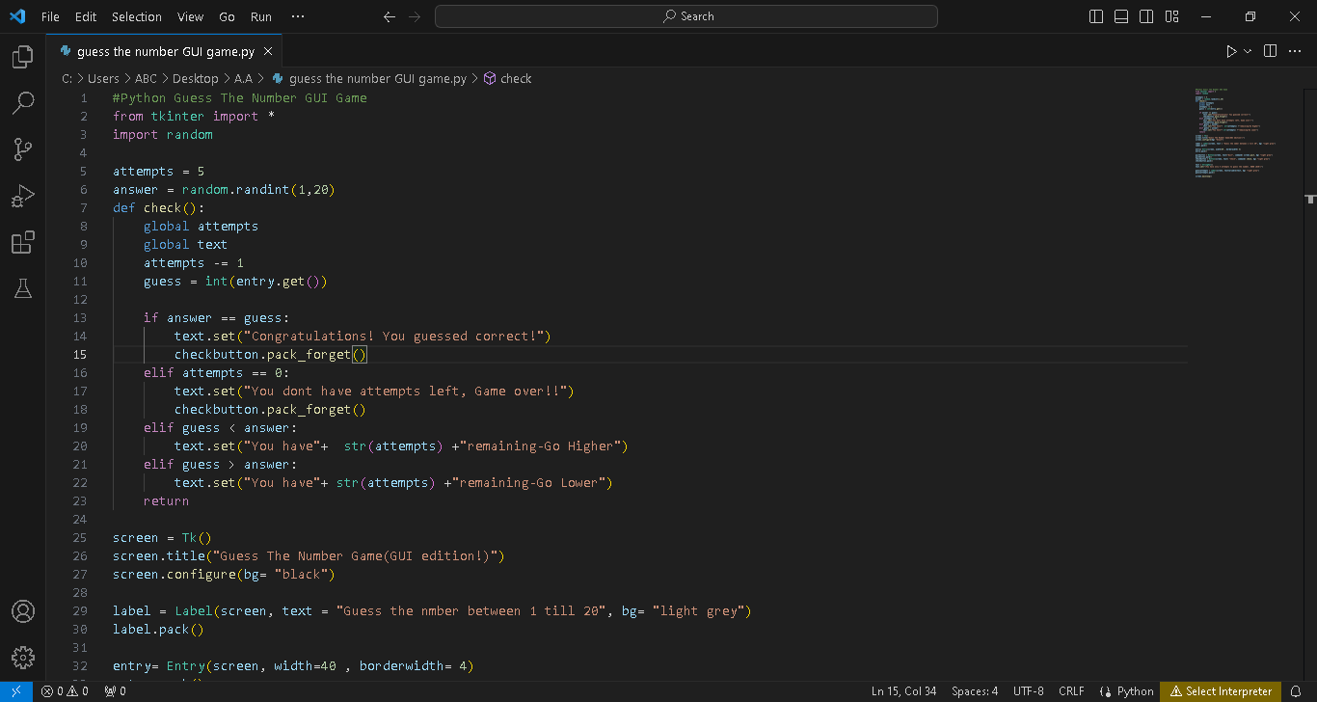

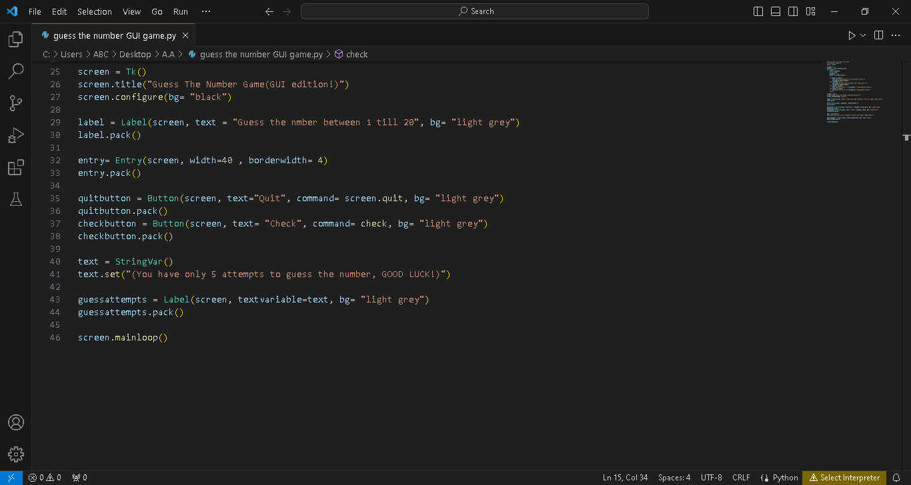

Here are screenshots of game:

